Name _________________________________

|  |  |  |
| --- | --- | --- |
| Basic Event | Frequency  Faults/year | Probability |
|  | 0.6 |  |
|  | 1.1 |  |
|  | 3.7 |  |
|  | 1.7 |  |
|  | 2.0 |  |
|  | 1.4 |  |
|  | 0.42 |  |

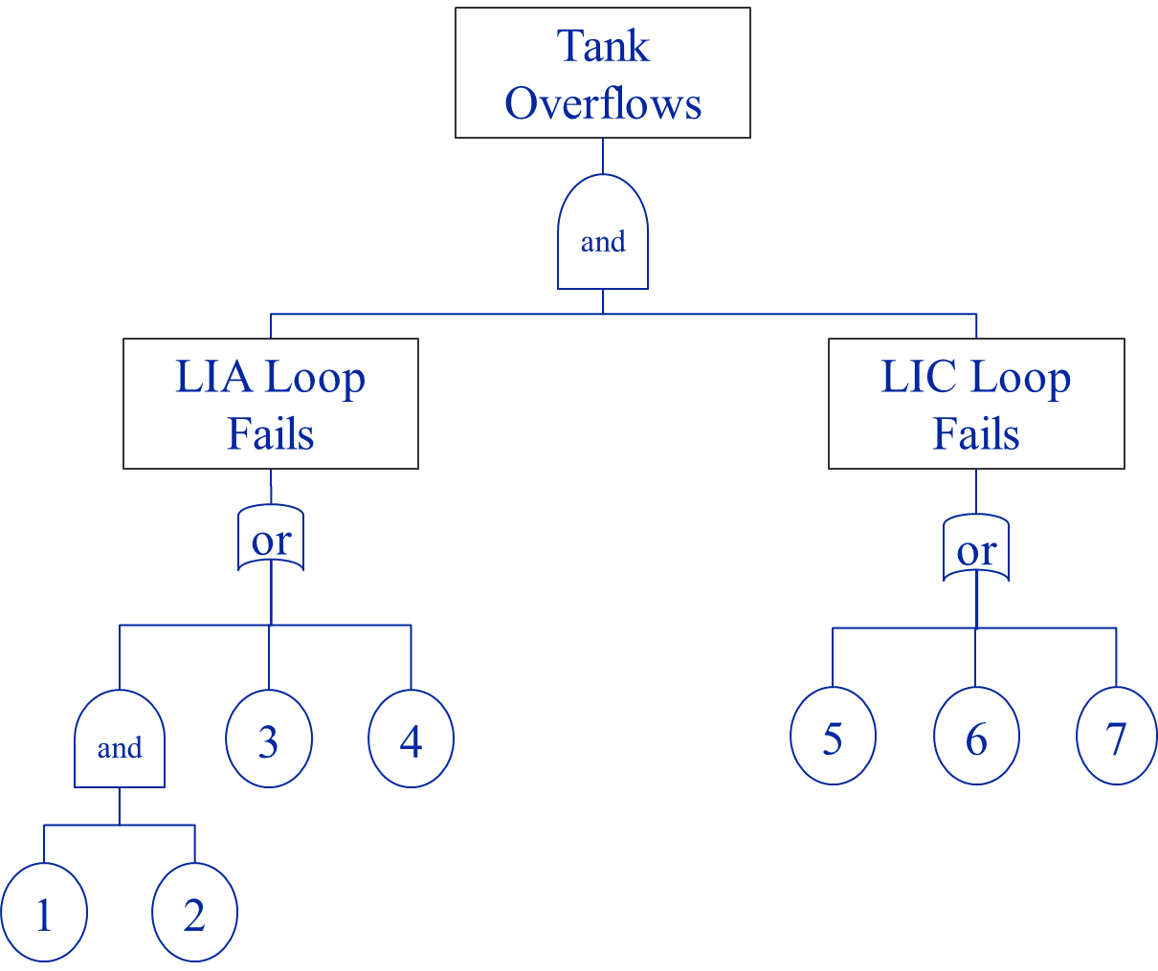

**Determine the Cut Sets**

**Determine the Probability and Frequency of the Top Event (T)**